National University of Technology (NUTECH)
IJP Road, Sector I-12
Islamabad
Telephone : 051-5476805
106/SCM/NUTECH
06 January 2021
To: M/s

Subject: Request for Quotation: - Comp Lab Equipment-2 (PSDP)

Please provide quotation for following items. Quotes will be submitted in closed envelop and must reached to SCM Office latest by 13 January 2021 before 1100 hrs.
Ser |  | Item | Specifications |  | A/U | Country of Origin | Qty Req | Price/Unit | Total Price
 |  | Magnifying lens with in-built light | - Super bright 60 or higher ultra-efficient SMD LEDs  - Equipped with strong internal springs in the arm  - Covered arm for full protection  - Lamp head with stainless steel ring for decoration  - Integrated handle for easy positioning  - Heavy duty metal G-clamp  - Colour temperature 6000 ... 6500 K  - Luminous flux at least 950 lumen  - Heavy-duty fastening clamp with 5 ... 60 mm opening  - Working radius: approx. 1 m  Sample picture is attached in Annexure “A”  Specs:  - Lens: Glass  - Colour: White  - Magnification: 1.75x or higher  - Diameter lens: 127mm or higher  - Energy Class: A+ |  | No | Any | 2
 |  | FM Transmitter Module | - FM Transmitter Module 85MHz-108MHz |  | No | Any | 10
 |  | Metal Detector | - DC 3V-5V 60mm Metal Detector Kit Non-contact Sensor |  | No | Any | 10
 |  | Cabinet Organizer  (Large) | - 39 or higher Drawers clear hard plastic storage box organizer.  - Grid design in divided box keeps items in compartments from migrating.  - The single drawer body is transparent, can see objects inside the box.  - Can hang on the wall and also can put on table.  - 9 or higher large drawers and 30- or higher small drawers (As per Annex B) |  | No | Any | 3
 |  | Soldering Station (Digital) | - Input Voltage: AC 220V $\sim$ 240V  - Input Frequency: 50/60Hz  - Plug type: 13A fused 3 pin plug  - Power Output: 50W  - Temperature Range: 200 $\sim$ 480 C  - Tip and ground impedance :<2 Ohm  - Tip and ground potential :< 2mV  Include:  - 230V AU Plug soldering station  - 907 soldering handle  - Iron holder  - User manual  Or Equivalent |  | No | Any | 20
 |  | Stepper motor | - 5v Stepper Motor + ULN2003 Driver 28Byj-48  Or Equivalent |  | No | Any | 12
 |  | Servo motor | - Hitec HS-422 Servo Motor, 180 degree  Or Equivalent |  | No | Any | 12
 |  | Arduino MKR GSM 1400 | - Arduino MKR GSM 1400 |  | No | Any | 3
 |  | Arduino ETHERNET SHIELD W5100 R3 | - Arduino ETHERNET SHIELD W5100 R3 |  | No | Any | 5
 |  | Arduino MKR WIFI 1010 | - Arduino MKR WIFI 1010 |  | No | Any | 3
 |  |  |  | Net Total (Without Taxes)
 |  |  |  | Total Taxes
 |  |  |  | Gross Total inclusive of all taxes

- Please provide unit price of each item, Total price per item, Total price of all items without all applicable taxes and total price with all taxes.
- Please also mention date of quote, NTN and STRN number in your quotation.
- Delivery period will be 5 days from the day of placing order.
- Rates shall be quoted on free delivery basis at NUTECH Islamabad.
- Please ensure delivery within stipulated time.
- Quotes must reach in SCM Office 2nd Floor Admin Block NUTECH Islamabad latest
by 13 Jan 2021.
7. The same RFQ may also be available on NUTECH Website i.e https://nutech.edu.pk/downloads/procurement/rfqs/
- Quotes will be opened on 13 January 2021.
- 100% payment will be made after successful completion of the order and user
satisfaction.

Deputy Assistant Director
Ehsan Ul Haq
Supply Chain Management Office

Annexure A (Magnifying lens with in-built light)

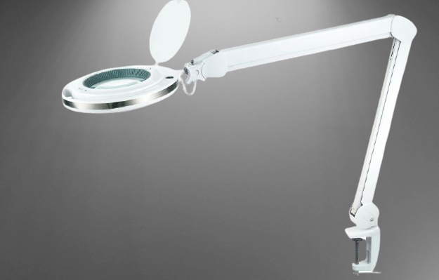

Annexure B (Cabinet Organizer)
