|  |  |
| --- | --- |
|  | National University of Technology (NUTECH)  IJP Road, Sector I-12  Islamabad  Telephone : 051-5476805  106/SCM/NUTECH  19 March 2021 |

To: M/s

Subject: Request for Quotation**: - NIC Equipment-1**

**Please provide quotation for following items. Quotes will be submitted in closed envelop and must reached to SCM Office latest by 26 March 2021 before 1200 hrs.**

|  |  |  |  |  |  |  |  |  |  |
| --- | --- | --- | --- | --- | --- | --- | --- | --- | --- |
| **Ser** | | **Item** | **Specifications** | | **A/U** | **Country of Origin** | **Qty Req** | **Price/Unit** | **Total Price** |
|  | | Soldering Iron Kit | Product description Specification of Soldering Iron: Work voltage: 110V; Power: 60W; Temp range: 200°C~450°C; Soldering Iron Length: 7.0 In; Cable Length: 59.0 In ; Package Include: 1 x Adjustable Temperature Soldering Iron (60W 110V) 1 x Solder Wire (82%Sn, 18%Pb, 1mm Dia., 0.71 oz) 5 x Extra Soldering Iron Tips  (Sample Picture attached at Annex A)  **OR Equivalent** | | No | Any | 4 |  |  |
|  | | Hot Air rework system | Hot Air/Soldering Iron Rework Station with Digital Display: **BASIC ELECTRICAL SPECIFICATIONS:**  VAC input: 110 V +/- 10%  Machine total Power: 700 watts max  Hot Air Power: 550 watts max  Soldering iron Power: 50 watts max  Temperature Range Hot Air Gun: 212 deg F to 842 deg F (100 deg C to 450 deg C)  Temperature Range Soldering Iron: 392 deg F to 896 deg F (200 deg C to 480 deg C)  Mode of Airflow: Diaphram pump  Airflow: 24L/min. max  Display: LED  Heating Elements: pump: Ceramic skeleton/ Soldering Iron: Ceramic Temperature Control: PID Digital Program every 200 ms  Tips to ground Impedance (soldering iron): <2 ohms  Tip voltage to ground: <2mV  Includes (1) KD-M-0.8D 0.8mm Chisel Tip and (4) Hot Air nozzels **Technical Specifications:** **Wattage:** 0-50 WATT  **Temp Range:** 212-542F  **Sleep Timer:** YES  **Hot Air Gun:** INCLUDED  (Sample Picture attached at Annex B)  **OR Equivalent** | | No | Any | 2 |  |  |
|  | | Magnifying lens with built-in light | 30X high power  12 pieces of LED lights  3.15-inches diameter  Double glass lenses  Wide application  (Sample Picture attached at Annex C)  **OR Equivalent** | | No | Any | 3 |  |  |
|  | | Almirah | Size/Dimension: 77*36*19 (H*W*D) INCHES  Number Of Shelve = 3  (Sample Picture attached at Annex D)  **OR Equivalent** | | No | Any | 3 |  |  |
|  | | Tools/Equipment Racks | **Equipment racks- Height x Width x Length: 5´ x 3´ x 12´**  5 Shelves pillars: Laminated guage 14  Load bearing capacity 50 Kg per shelve  (Sample Picture attached Annex E)  **OR Equivalent** | | No | Any | 2 |  |  |
|  | | Consumable Items Racks | Electronics Consumable Racks  Number of boxes = 30  (Sample Picture attached at Annex F) | | No | Any | 5 |  |  |
|  |  | |  | **Net Total (Without Taxes)** | | | |  |  |
|  |  | |  | **Total Taxes** | | | |  |  |
|  |  | |  | **Gross Total inclusive of all taxes** | | | |  |  |

1. Please provide unit price of each item, Total price per item, Total price of all items without all applicable taxes and total price with all taxes.
2. Please also mention date of quote, **NTN** and **STRN** number in your quotation.
3. Delivery period will be 10 days from the day of placing order.
4. Rates shall be quoted on free delivery basis at NUTECH Islamabad.
5. Please ensure delivery within stipulated time.
6. Quotes must reach in SCM Office 2nd Floor Admin Block NUTECH Islamabad latest

by 26 March 2021 before 1200 hrs.

7. The same RFQ may also be available on NUTECH Website i.e https://nutech.edu.pk/downloads/procurement/rfqs/

1. **LD will be imposed as per rules**.
2. **Quotes will be opened on 26 March 2021.**
3. 100% payment will be made after successful completion of the order.

Deputy Assistant Director

Supply Chain Management Office

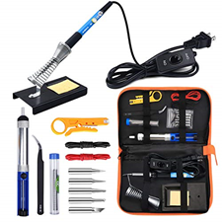**Annexure-A Annexure-D**



**Annexure-B Annexure-E**

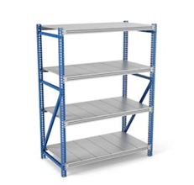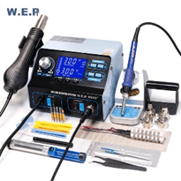

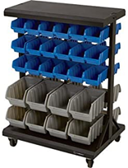**Annexure-C Annexure-F**

