National University of Technology (NUTECH)
IJP Road, Sector I-12
Islamabad
Telephone : 051-5476805
106/SCM/NUTECH
19 March 2021
To: M/s

Subject: Request for Quotation: - NIC Equipment-2

Please provide quotation for following items. Quotes will be submitted in closed envelop and must reached to SCM Office latest by 26 March 2021 before 1200 hrs.
Ser | Item | Specifications |  | A/U | Country of Origin | Qty Req | Price/Unit | Total Price
 | Temperature Humidity Pressure Sensor  Adafruit BME280 I2C or SPI  Or Equivalent | Sensor for measurement of environmental parameters with temperature, barometric pressure and humidity.  (Sample Picture attached at Annex A) |  | No | European / North American | 20
 | S.T.E.A.M. Building Kit with Animatronics  Meccano, Motorized Movers  or Equivalent | Inside a re-useable case, our future engineer will find everything they need to construct their own creations and animate them  Specification: (minimum)  - 196 Parts  - 1 Motor  - 1 Maker Tool  - 8 Blueprints  - 1 Instruction Manual  (Sample Picture attached at Annex B) |  | No | European | 2
 | 4wd RC smart car chassis metal servo & bearing kit for arduino | 4-wheel car chassis  Specifications (minimum):  Motor work voltage: 6-12V  Servo model: MG996  Car size: 248mm(l) x 146mm(w) x 70mm(h)  Weight: 680g  Package list  Metal chassis x 1  Acrylic chassis x 2  65 MM wheels x4  Anti-collision cotton x1  Metal gear motor x1  Engine counting bracket x1  Steering wheel x 2  Rear-wheel link x1  Rolling bearing flange x2  17 MILLIMETERS D-5MM coupling x2 MG996R actuator x1  Servo arm x1  L Mount bracket x1  Sector x 2  Pull rod x2  Steering bellcrank x2  Transmission link x2  Bearing (8mm) x 2  Bearing (12mm) x 2  Aluminum column x 2  Hexagon adapter x 2  Switch x1  M3 * 16mm passage double copper column x 4 M3 * 16mm  M3 * 22mm passage double copper column x 8 M3 * 22mm  M3 * 35mm passage double copper column x 4 M3 * 35mm  M3 * 5mm head screwdriver x2  M3 * 5mm screwdriver x5  M3 * 8mm screwdriver x40  M2.5 * 10mm Screw x 8  M3 locknut x 8  M2.5 locknut x 1  M4 locknut x 2  Gasket x4  Cross sleeve x1  Cable ties x6  22AWG wire x 3  (Sample Picture attached at Annex C) |  | No | Imported | 3
 | Basic temperature-humidity sensor + extras  DHT11  Or equivalent | Ultra low-cost digital temperature and humidity sensor. Use a capacitive humidity sensor and a thermistor to measure the surrounding air, and spits out a digital signal on the data pin (no analog input pins needed). Its fairly simple to use, but requires careful timing to grab data.  3 to 5V power and I/O  2.5mA max current use during conversion (while requesting data)  Good for 20-80% humidity readings with 5% accuracy  Good for 0-50°C temperature readings ±2°C accuracy  No more than 1 Hz sampling rate (once every second)  Body size 15.5mm x 12mm x 5.5mm  4 pins with 0.1" spacing  (Sample Picture attached at Annex D) |  | No | European / North American | 10
 | Triple-axis Accelerometer+Magnetometer (Compass) Board)  LSM303  Or equivalent | Inside are two sensors, one is a classic 3-axis accelerometer, which can tell we which direction is down towards the Earth (by measuring gravity). The other is a magnetometer that can sense where the strongest magnetic force is coming from, generally used to detect magnetic north.  The compact sensor should use I2C to communicate, a 3.3V max chip, added circuitry to make it 5V-safe logic and power, for easy use with either 3 or 5V microcontrollers. Simply connect VCC to +3-5V and ground to ground. Then read data from the I2C clock and data pins.  (Sample Picture attached at Annex E) |  | No | European / North American | 10
 | Experimentation Kit for Metro 328  Adafruit MetroX Classic Kit or equivalent | Specification: (minimum)  At the heart it must be ATmega328P, with 32KB of flash and 2KB of RAM, running at 16 MHz.  Includes:  Arduino Prototyping Bundle (the latest Adafruit Metro, half size breadboard & acrylic holder)  65 Piece Jumper Wire Bundle  Full color printed 32-page Experimenter's Guide  13 color Breadboard Layout Sheets  USB Cable  9V battery clip  Micro Servo  DC Toy Motor  Mini Remote Control  16x2 LCD + extras  Force Sensitive Resistor  Loads of components:  1x 10K Pot  1x Piezo Buzzer  3x 10K 5% Resistors  3x 2.2K 5% Resistors  2x IN4001 Diode  1x 5V Relay  1x TMP36 Temperature Sensor  25x 560ohm 5% Resistors  1x 74HC595 Chip  3x Extra-long Servo Pin  1x Headphone Jack  2x PN2222  1x 220uF / 6.3V Electrolytic Capacitor  16-pin Male Header  2x 12mm Tactile Switch  1x IR Sensor  1x HW-5P-1 Light Sensor  1x 5mm IR LED  1x Diffused RGB LED  1x Diffused 10mm Blue LED  10x Diffused Red 5mm LED  10x Diffused Green 5mm LED  (Sample Picture attached at Annex F) |  | No | European / North American | 4
 | Ultrasonic Distance Sensor - 3V or 5V  HC-SR04 compatible - RCWL-1601  or equivalent | 3V Ultrasonic Sonar Distance Sensor and a pair of flippers.  Should work at about 2cm to 450cm away  (Sample Picture attached at Annex G) |  | No | European / North American | 12
 | Photo cell  (CdS photoresistor) | CdS cells are little light sensors. As the squiggly face is exposed to more light, the resistance goes down. When its light, the resistance is about ~1KΩ, when dark it goes up to ~10KΩ.  Dimensions (minimum):  Length: 4.46mm/0.18in  Width: 5mm/0.20in  Height: 2.09mm/0.08in  Weight: 0.25g/0.01oz  (Sample Picture attached at Annex H) |  | No | European / North American | 20
 | Analog 2-axis Thumb Joystick with Select Button + Breakout Board | The thumbstick is an analog joystick - more accurate and sensitive than just 'directional' joysticks - with a 'press in to select' button.  Specification (minimum):  Dimensions: 1.5" wide x 1.5" long x 1.25" tall (when assembled)  Weight: 12 grams ( 0.4oz )  Power: Usable with any voltage up to 5V, 2 analog outputs. 1 milliamp draw when used with 5V  (Sample Picture attached at Annex I) |  | No | European / North American | 10
 | Temperature, Humidity, Pressure and Gas Sensor - STEMMA QT  Adafruit BME680  Or equivalent | Should contain temperature, humidity, barometric pressure, and VOC gas sensing capabilities. All over SPI or I2C at a great price  (Sample Picture attached at Annex J) |  | No | European / North American | 10
 |  |  | Net Total (Without Taxes)
 |  |  | Total Taxes
 |  |  | Gross Total inclusive of all taxes

- Please provide unit price of each item, Total price per item, Total price of all items without all applicable taxes and total price with all taxes.
- Please also mention date of quote, NTN and STRN number in your quotation.
- Delivery period will be 10 days from the day of placing order.
- Rates shall be quoted on free delivery basis at NUTECH Islamabad.
- Please ensure delivery within stipulated time.
- Quotes must reach in SCM Office 2nd Floor Admin Block NUTECH Islamabad latest
by 26 March 2021 before 1200 hrs.
7. The same RFQ may also be available on NUTECH Website i.e https://nutech.edu.pk/downloads/procurement/rfqs/
- LD will be imposed as per rules.
- Quotes will be opened on 26 March 2021.
- 100% payment will be made after successful completion of the order.

Deputy Assistant Director
Supply Chain Management Office

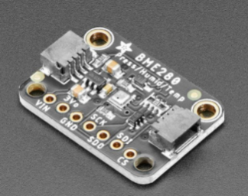
Annexure-A Annexure-F
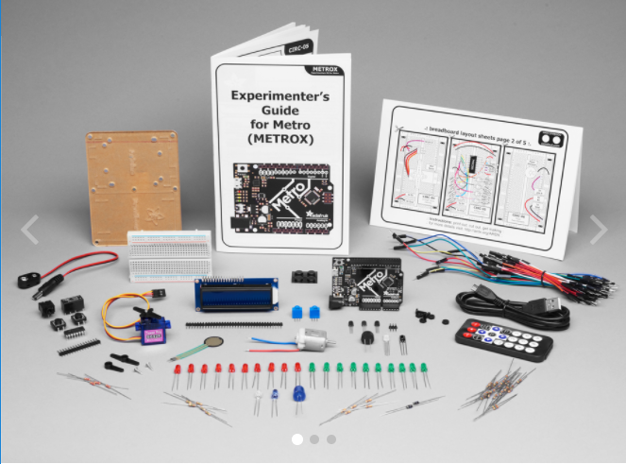
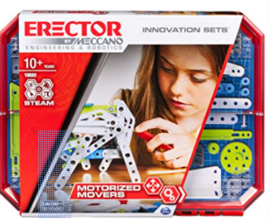
Annexure-B Annexure-G
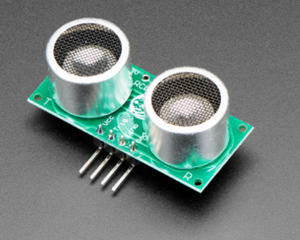
Annexure-C Annexure-H
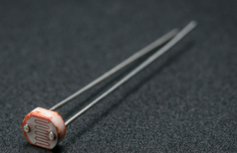
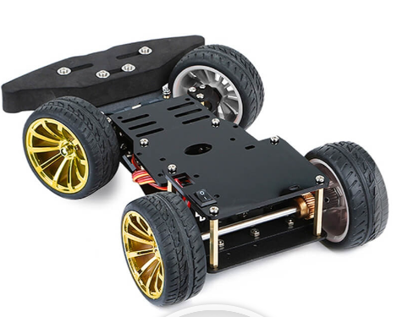

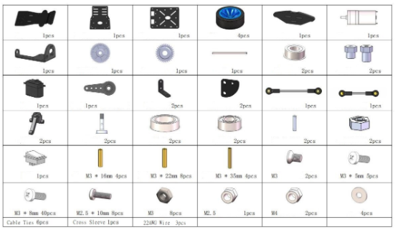
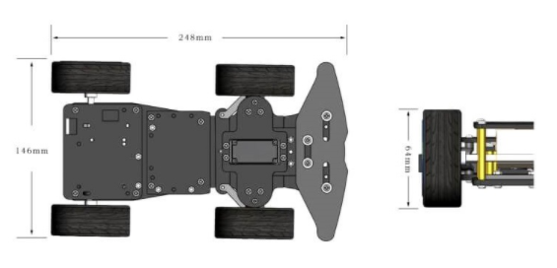 Annexure-I
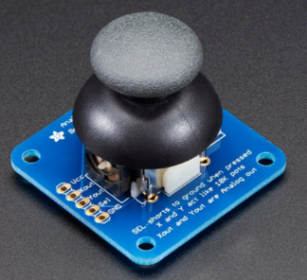
Annexure-D
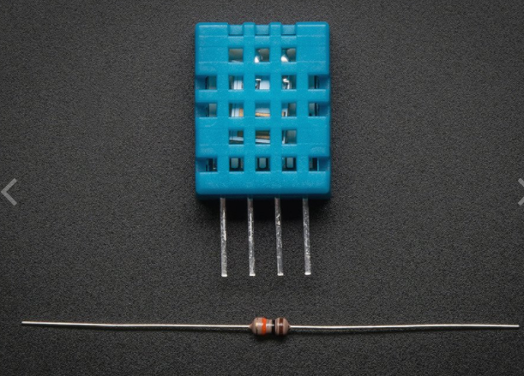

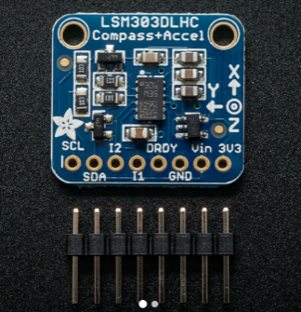
Annexure E
Annexure-J
