National University of Technology (NUTECH)
IJP Road, Sector I-12
Islamabad
Telephone : 051-5476805
106/SCM/NUTECH
19 March 2021
To: M/s

Subject: Request for Quotation: - NIC Equipment-3

Please provide quotation for following items. Quotes will be submitted in closed envelop and must reached to SCM Office latest by 26 March 2021 before 1100 hrs.
Ser | Item | Specifications |  | A/U | Country of Origin | Qty Req | Price/Unit | Total Price
 | Electret Microphone Amplifier –  MAX4466 with Adjustable Gain  Or equivalent | This fully assembled and tested board comes with a 20-20KHz electret microphone soldered on. For the amplification, we use an op-amp specifically designed for this delicate task! The amplifier has excellent power supply noise rejection, so this amplifier sounds really good and isn't nearly as noisy or scratchy  We can set the gain from 25x to 125x. That's down to be about 200mVpp (for normal speaking volume about 6" away) which is good for attaching to something that expects 'line level' input without clipping, or up to about 1Vpp, ideal for reading from a microcontroller ADC. The output is rail-to-rail so if the sounds gets loud, the output can go up to 5Vpp! |  | No | European / North American | 10
 | Round Force-Sensitive Resistor (FSR)  Interlink 402  Or equivalent | FSRs made of plastic and the connection tab should crimped on delicate material.  Dimensions (minimum):  Length: 56.77mm/2.35in  Width: 18.48mm/0.73in  Thickness: 0.55mm/0.02in  Weight: 0.26g/0.01oz |  | No | European / North American | 10
 | Rotary Encoder + Extras | It’s a high quality 24-pulse encoder, with detents. It is panel mountable for placement in a box, or we can plug it into a breadboard (just cut/bend the two mechanical side tabs. |  | No | European / North American | 10
 | Analog UV Light Sensor Breakout  GUVA-S12SD  Or equivalent | Should have a UV photodiode, which can detect the 240-370nm range of light (which covers UVB and most of UVA spectrum). The signal level from the photodiode is very small, in the nano-ampere level, so we tossed on an opamp to amplify the signal to a more manageable volt-level. |  | No | European / North American | 5
 | High Quality HQ Camera - 12MP | It offers higher resolution (12.3 megapixels, compared to 8 megapixels), and sensitivity (approximately 50% greater area per pixel for improved low-light performance) than the existing Camera Module v2, and is designed to work with interchangeable lenses in both C- and CS-mount form factors. Other lens form factors can be accommodated using third-party lens adapters.  Must be compatible with Raspberry Pi 4. |  | No | European/ North American | 3
 | Leap Motion Controller with SDK | We can integrate our Leap Motion Controller with an Arduino, map our hand motions to our favorite robot, or drive a remote-controlled car over Wi-Fi.  Highly accurate hand and finger tracking with near-zero latency  8 cubic feet of interactive 3D space  135° field of view extending above the device  Compact device at 3" / 80mm long  USB connection |  | No | European / North American | 3
 | Anemometer Wind Speed Sensor w/Analog Voltage Output | An anemometer is a device used for measuring wind speed, and is a common weather station instrument. This well-made anemometer is designed to sit outside and measure wind speed with ease.  Specifications (minimum):  Output: 0.4V to 2V  Testing Range: 0.5m/s to 50m/s  Start wind speed: 0.2 m/s  Resolution: 0.1m/s  Accuracy: Worst case 1 meter/s  Max Wind Speed: 70m/s |  | No | European / North American | 2
 | Motor/Stepper/Servo Shield for Arduino v2 Kit - v2.3 | MOSFET drivers with 1.2A per channel current capability (we can draw up to 3A peak for approx 20ms at a time).  It should have much lower voltage drops across the motor so we get more torque out of our batteries, and there are built-in flyback diodes as well. |  | No | European / North American | 3
 | Embedded Hardware for Hobby Application  Arduino Pro Mini 328 - 3.3V/8 MHz or equivalent | It should have a 3.3v board that can runs an 8 MHz bootloader on a super small, super thin board. |  | No | European / North American | 5
 | Personal Computer Kit - US Version  Raspberry Pi 400 or equivalent | It is basically a keyboard, combined with a custom-designed PCB. Furthermore, it contains everything we need to get started with an included mouse and a 16GB micro-SD card pre-installed with Raspberry Pi OS.  Featuring a quad-core 64-bit processor, wireless networking, dual-display output, and 4K video playback, It is a complete personal computer, built into a compact keyboard. |  | No | Imported | 3
 |  |  | Net Total (Without Taxes)
 |  |  | Total Taxes
 |  |  | Gross Total inclusive of all taxes

- Please provide unit price of each item, Total price per item, Total price of all items without all applicable taxes and total price with all taxes.
- Please also mention date of quote, NTN and STRN number in your quotation.
- Delivery period will be 10 days from the day of placing order.
- Rates shall be quoted on free delivery basis at NUTECH Islamabad.
- Please ensure delivery within stipulated time.
- Quotes must reach in SCM Office 2nd Floor Admin Block NUTECH Islamabad latest
by 26 March 2021 before 1100 hrs.
7. The same RFQ may also be available on NUTECH Website i.e https://nutech.edu.pk/downloads/procurement/rfqs/
- LD will be imposed as per rules.
- Quotes will be opened on 26 March 2021.
- 100% payment will be made after successful completion of the order.

Deputy Assistant Director
Supply Chain Management Office

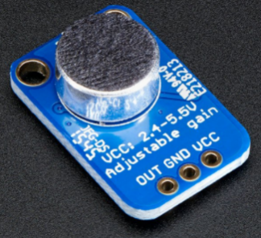
Annexure-A Annexure-F
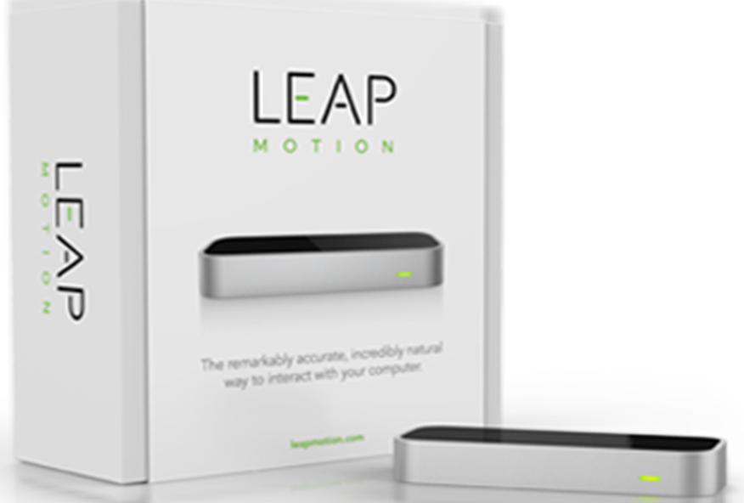
Annexure-B Annexure-G
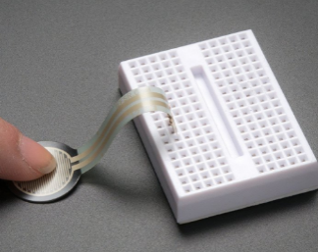
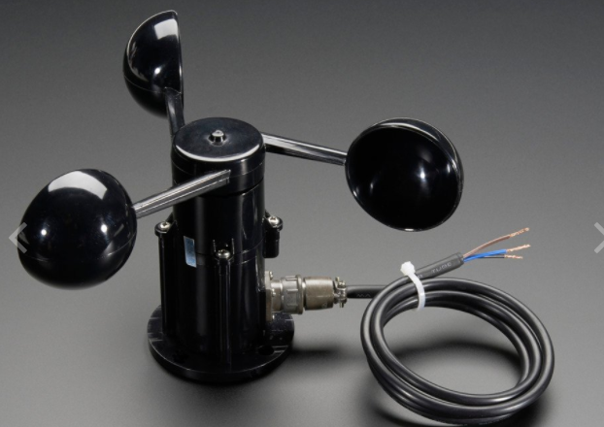
Annexure-C Annexure-H
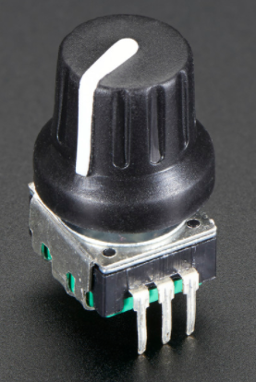
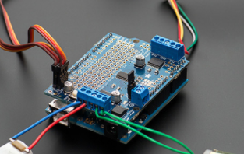
Annexure-I
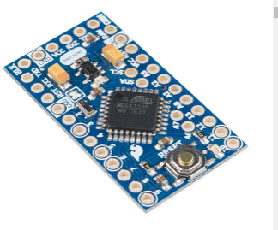
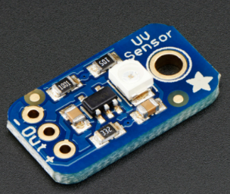
Annexure-D

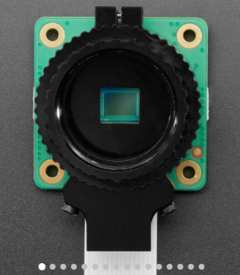
Annexure E
Annexure-J
