National University of Technology (NUTECH)
IJP Road, Sector I-12
Islamabad
Telephone : 051-5476805
106/SCM/NUTECH
31 May 2021
To: M/s

Subject: Request for Quotation: - Mech Lab Tools

Please provide quotation for following items. Quotes will be submitted in closed envelop and must reached to SCM Office latest by 03 June 2020 before 1100 hrs.
Ser |  | Item | Specifications |  | A/U | Country of Origin | Qty Req | Price/Unit | Total Price
 |  | Chisel Set | - 6 pcs set  - Sizes: 6mm, 10mm, 16mm, 19mm, 25mm, 32mm  - Rubber Handle  - Shape: flat, round, half round, Cross-cut and diamond shaped  - Made of chrome vanadium steel  - Surface machine scrub  - High carbon steel blades |  | No | Any | 5
 |  | C-Clamp | - Round steel double-headed wire C-clamp  - Size: 6inch  - Quick release  - Material: round steel (A3 or carbon steel)  - surface treatment: Spray molding  - screw surface treatment: chrome  - Opening capacity: 3 inches or more  - Throat depth: Approx. 2 inches  - Load limit: Approx. 800 pounds |  | No | Any | 2
 |  | Vernier Calipers | - 0-150mm 6 inch analogue Vernier caliper measuring tool  - Standard: DIN862  - Material: Hardened stainless steel  - Respond speed: 3M/S  - Battery: 1.5V  - Accuracy: +/-0.002"  - Resolution: 0.0078" |  | No | Any | 5
 |  | Micrometer Screw Gauge | - 0.001mm analogue outside 0-25mm 25-50mm 50-75mm 75-100mm gauge micrometer screw gauge  - size: 0-25-50-75-100mm  - Material: Stainless Steel  - Type: Micrometer  - Resolution: 0.001mm  - High Accuracy |  | No | Any | 5
 |  | Chipping hammer | - Size: 200-500g  - Hammer Head: S45C/S50C/S55C Steel, Drop Forged, Heat Treated, Strike Surface Hardness: HRC 45-58  - Superficial Treatment: Sandblasting, Painting, Baking Varnish, Power Coat, Polished, Mirror Polished, Chrome-plate  - Head And Handle Fixation: Wedge, Epoxy Glue, Sturdy And Durable |  | No | Any | 5
 |  | Digital Multi-meter | - DC Voltage: 200mV / 2V / 20V / 200V / 1000V, best accuracy: +/- (0.05%+3)  - AC Voltage: 2V / 20V / 200V / 1000V, best accuracy: +/- (0.5%+10)  - DC Current: 2mA / 200mA / 20A, best accuracy: +/- (0.5%+5)  - AC Current: 20mA / 200mA / 20A, best accuracy: +/- (0.8%+10)  - Resistance: 200 Ohm / 2 kOhm / 20 kOhm / 2 MOhm / 200 MOhm, best accuracy: +/- (0.5%+10)  - Capacitance: 2nF / 20nF / 2µF / 20µF, best accuracy: +/- (3%+40)  - Temperature: from -40 to +1000°C, best accuracy: +/- (1%+30)  - Frequency: 20kHz, best accuracy: +/- (1.5%+5) |  | No | Any | 2
 |  | Analog Multi-meter | - Professional analog multi-meter 390C  - Measuring Current Range: 0.1-250mA  - Measuring Voltage Range: 0.25-1000v  - Measuring Resistance Range: 0.1Ω-20MΩ  - Operating Temperature: 0-40℃  - transistor test: yes  - continuity buzzer test: yes  - decibel test: yes |  | No | Any | 5
 |  | Soldering and Hot air Gun | - Soldering and Hot Air Gun 2 in 1 Rework Station  - Voltage: 220V/50HZ  - Operating Temperature: 0-40℃  - Current: 4A  - Model Number: 8586  - Type: Digital  - Temperature Control Accuracy: ± 2°c  - Tip Type: Knife, Needle, Straight  - dBA: >52DB(A)  - Material: Carbon/Blend |  | No | Any | 1
 |  | Wire cutter and striper | - 2 in 1 Adjustable Automatic Cable Wire Stripper and Cutter  - Type: Locking Pliers  - Application: Wire Stripper  - strip size: 0.2mm-6mm  - Material: Carbon Steel |  | No | Any | 2
 |  | Blower | - 50mm fan blower  - Air Volume: 2.50~3.10CFM  - Speed: 3800RPM  - Electric Current Type: DC  - Blade Material: Plastic  - Type: Centrifugal Fan  - Bearing Type: Ball Bearing  - Voltage: 12V 24V |  | No | Any | 1
 |  | Rechargeable drill machine | - 12V cordless drill including battery and charger cordless drill electric cordless battery  - Drill Type: cordless  - Voltage: 12V  - Charging Time: 3-5hours  - Type: Li-ion Battery Cordless Drill  - No-Load Speed: 0-700rpm  - Torque Setting: 17+1  - Battery: 1300mah  - Motor: 550 Motor  - Chuck: 0.8-10mm  - Speed: 1500RPM |  | No | Any | 2
 |  | Facing  Turning  External &Internal Threading  Parting  Boring  Knurling tools for Lathe Machine | - Length: 150mm  - Width: 20mm  - Type: H.S.S Cutting Tools  - 5 each |  | No | Any | 35
 |  | Steel Rods for Lathe Machines | - Diameter: 70mm  - Length: 200mm  - Type: Mild Steel |  | No | Any | 30
 |  | Drill Bits for Lathe Machine with Drill Shanks | - Diameter: 12 to 20 mm  - Type: Flat bit |  | No | Any | 5
 |  | Work piece for CNC Lathe Machine | - Diameter: 70mm  - Length: 200mm  - Type: Teflon |  | No | Any | 30
 |  | Handle for files | - Length: 2 to 5 inches  - Type: Plastic  - Picture attached as Annex-A |  | No | Any | 20
 |  | Coolant for Lathe Machine | - Active Synthetic Coolant  Operations: In cutting/grinding operations |  | Ltr | Any | 30
 |  | Brass Specimen | - Diameter: 10mm  - Length: 300mm  - Grade: C360  - Type: Round Brass bar  - Picture attached as Annex-B |  | No | Any | 10
 |  | Steel Specimen | - Diameter: 10mm  - Length: 300mm  - Grade: 40  - Type: Ribbed Bar  - Picture attached as Annex-B |  | No | Any | 10
 |  | Iron Specimen | - Diameter: 10mm  - Length: 300mm  - Grade: 40  - Type: Plain Bar  - Picture attached as Annex-B |  | No | Any | 10
 |  | Aluminium Specimen | - Diameter: 10mm  - Length: 300mm  - Grade: 6082  - Type: Round Aluminium Bar  - Picture attached as Annex-B |  | No | Any | 10
 |  |  |  | Net Total (Without Taxes)
 |  |  |  | Total Taxes
 |  |  |  | Gross Total inclusive of all taxes

- Please provide unit price of each item, Total price per item, Total price of all items without all applicable taxes and total price with all taxes.
- Please also mention date of quote, NTN and STRN number in your quotation.
- Delivery period will be 5 days from the day of placing order.
- Rates shall be quoted on free delivery basis at NUTECH Islamabad.
- Please ensure delivery within stipulated time.
- Quotes must reach in SCM Office 2nd Floor Admin Block NUTECH Islamabad latest
by 03 June 2021.
7. The same RFQ may also be available on NUTECH Website i.e https://nutech.edu.pk/downloads/procurement/rfqs/
- LD will be imposed as per rules.
- Quotes will be opened on 03 June 2021.
- Business will be awarded on package deal basis.
- 100% payment will be made after successful completion of the order.

Deputy Assistant Director
Supply Chain Management Office

Annex-A
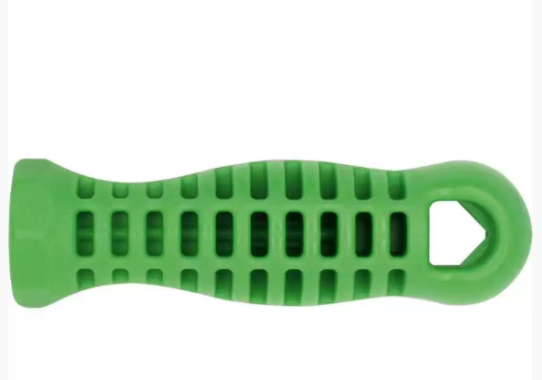
File Handle (For reference only)

Annex-B
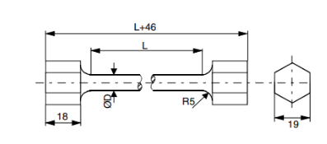
Sample dimension (For reference only)

