**1**. **Global overview**

[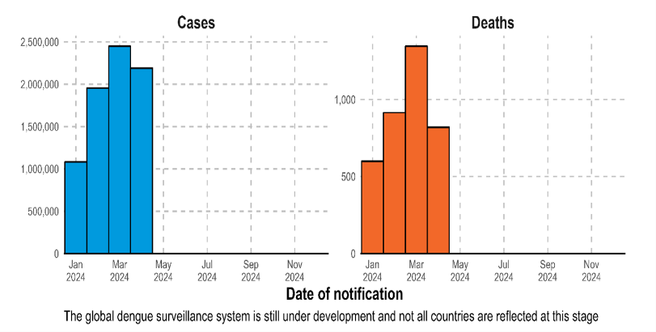](https://cdn.who.int/media/images/default-source/emergencies/disease-outbreak-news/dengue_epi.png?sfvrsn=217ea2ff_3)According to WHO reportas of 30 April 2024, over 7.6 million dengue cases have been reported to WHO in 2024, including 3.4 million confirmed cases, over 16 000 severe cases, and over 3000 deaths. While a substantial increase in dengue cases has been reported globally in the last five years, this increase has been particularly pronounced in the Region of the Asia, where the number of cases has already exceeded seven million by the end of April 2024, surpassing the annual high of 4.6 million cases in 2023. Furthermore, this is three times what was reported during the same period in 2023, highlighting the acceleration of this health problem.

2. In 2024, Pakistan is facing a significant dengue outbreak, with nearly **50,000 cases reported** nationwide. Dengue fever continues to be a significant public health issue in 2024, with ongoing outbreaks reported in major cities, especially Rawalpindi. As of mid-September 2024, Rawalpindi alone has recorded **368 confirmed cases** of dengue, with new cases emerging daily.This marks one of the worst dengue seasons in recent years, largely exacerbated by extended monsoon rains, which provide ideal breeding grounds for the **Aedes** mosquitoes that spread the virus​. Approximately **65% of the reported cases are male**, showing a 2:1 male-to-female ratio.

**2.** **What is dengue?** Dengue is a viral infection spread to humans by the bite of an infected Aedes mosquito. It's a mosquito-borne disease that's most common in tropical and subtropical areas, but it can also be found in other regions.

1. 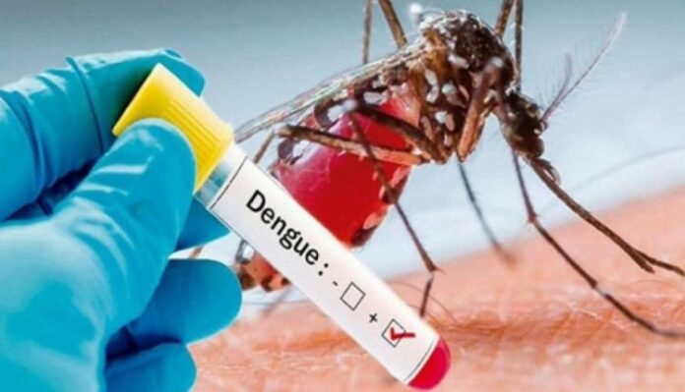**Cause.** The primary vectors that transmit the disease are Aedes aegypti and, to a lesser extent, Aedes albopictus mosquitoes. Dengue virus has four serotypes (DENV-1, DENV-2, DENV-3, DENV-4). Infection with one serotype provides long-term immunity to the same serotype and only transient immunity to the other serotypes, after which secondary infections with a different serotype increase the risk for severe dengue
2. **Transmission**
   1. **Mosquito bites:** Mosquitoes typically lay eggs in containers that hold water, like buckets, bowls, animal dishes, flowerpots, and vases. They prefer to bite people during the day and night. Different mosquitoes become infected with dengue virus when they bite a person infected with the virus and then these infected mosquitoes can spread the virus to other people through bites.
   2. **Mother to child:** A person who is infected with dengue virus during pregnancy can pass the virus to their fetus during pregnancy or around the time of birth and this can have harmful effects, including death of the fetus, low birth weight, and premature birth.
   3. **Blood transfusion**
   4. **Organ transfusion**
3. **Risk Factors**
   1. **L**iving in tropical or subtropical regions.
   2. Travelling to endemic areas
   3. Poor sanitation and waste management
   4. Standing water (breeding sites for mosquitoes)
   5. Lack of protective measures
4. **Symptoms.** Most people with dengue have no symptoms, or they have a mild illness that develops 4 to 7 days after being bitten. Most people recover after about a week. However, a small percentage of people develop severe dengue, which can be fatal.
   1. **Mild Dengue Fever:**
      1. High fever (up to 104°F or 40°C)
      2. Severe headache
      3. Pain behind the eyes
      4. Joint and muscle pain
      5. Nausea and vomiting
      6. Fatigue
      7. Skin rash
   2. **Severe Dengue (Dengue Hemorrhagic Fever):**
      1. Bleeding gums or nosebleeds
      2. Easy bruising
      3. Blood in vomit or stool
      4. Sudden drop in blood pressure (dengue shock syndrome)
      5. Severe abdominal pain
5. **Treatment.** Most people with dengue feel better in a few days. There is no treatment for dengue, but you can help ease your symptoms by:
   1. Rest
   2. Drinking plenty of fluids
   3. Home remedies
   4. Take Paracetamol to help bring down your temperature and ease any pain. Do not take anti-inflammatory painkillers like ibuprofen or aspirin. These can cause bleeding problems if you have dengue. If you have severe dengue, you'll need to stay in hospital until you recover.
6. **Precautions**
   1. Wear long-sleeved clothing and trousers to cover your arms and legs, particularly during early morning and early evening
   2. Use insect repellent on your skin
   3. Close windows and doors whenever possible, or use blinds or screens
   4. Sleep under a mosquito net treated with insecticide, including during the day
   5. Eliminate standing water
   6. 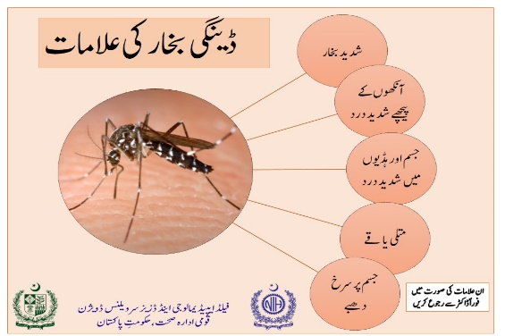Follow advisories issued by the government / authorities

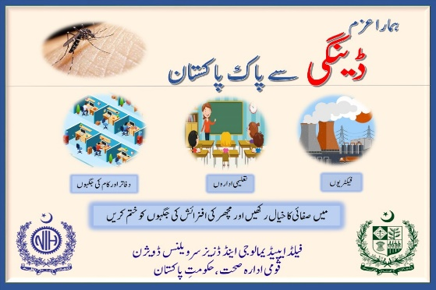

**3**. Immediately report any emergency case to MI Room for necessary professional medical attention.

