National University of Technology (NUTECH)
IJP Road, Sector I-12
Islamabad
Telephone : 051-5476805
106/SCM/NUTECH
10 Jan 2023
To: M/s
Subject: Request for Quotation: - Consumable for Computer Engineering Lab-PSDP
Please provide quotation for following items. Quotes will be submitted in closed envelop and must reach to SCM Office latest by 13 January 2023 before 1100 hrs.
Sr. | Item | Specifications | A/U | Country of Origin | OEM Auth Req (Yes/No) | Qty Req | Price/ unit Including Tax | Total Price Including Tax
1. | IC | 74LS26 | No | Any | No | 30
2. | IC | 74LS150 | No | Any | No | 30
3. | Transistor | 2N3819 | No | Any | No | 100
4. | Fuse | Fuse 215mA | No | Any | No | 30
5. | Fuse | Fuse 315mA  Picture for reference only  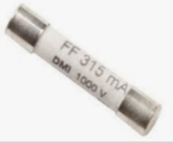 | No | Any | No | 30
6. | PVC Insulated Flexible Electric Cable | - PVC Insulated flexible cable 1 Core 23/76 Electric Wire | meter | Any | No | 90 meters only
7. | Crocodile Clips Set | - 45mm Crocodile Clips Set Alligator Clip (Red & Black Set)  Picture for reference only  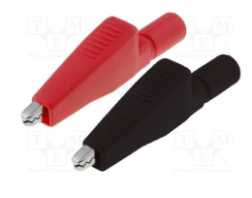 | set | Any | No | 210
8. | Vero board | - Dotted 100mm x 240mm  Picture for reference only | No | Any | No | 10
9. | Male Headers | - 40 Pin Male Header  - 2.54mm (0.1″)  - 40-pin break away single row male header  Picture for reference only  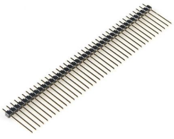 | No | Any | No | 200
10. | 9 Volt Battery DMM | - 9V Alkaline Battery  Picture for reference only  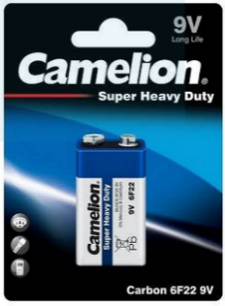 | No | Any | No | 50
11. | Rack cage nuts | - Material: Nickle plated iron  - Size:M5*16 or M5*20 or M6*16 or M6*20  - Pack: 20 PCs  Picture for reference only  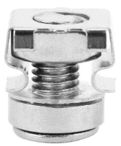 | pack | Any | No | 1
12. | THUMBSCREWS for VOLTERA | - 10 mm long Thumb Screws  - Pack: 4 PCs  Picture for reference only  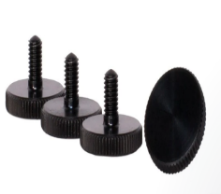 | pack | Any | No | 2
13. | Disposable NOZZLES - 225 MICRON for VOLTERA | - 0.225mm Nozzle  - Pack: 4 PCs  Picture for reference only  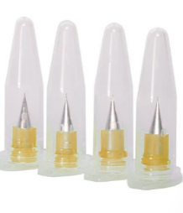 | pack | Any | No | 1
14. | SOLDER PASTE CARTRIDGE T5 - SN63PB37 for VOLTERA | - Particle size — T5  - Alloy — Sn63Pb37  - Reflow — 240°C until fully melted.  Picture for reference only  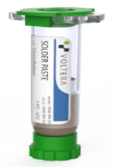 | No | Any | No | 1
15. | CONDUCTOR 2 INK CARTRIDGE for VOLTERA | - Curing temperature is 16°C for 30 minutes  - Compatible with FR1 and FR4 substrates  Picture for reference only  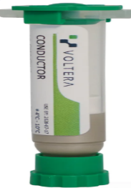 | No | Any | No | 2
16. | SMD Timer IC | - LM556CM Dual Timer SMD SOP-14  Picture for reference only  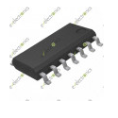 | No | Any | No | 50
17. | IC | PIC 18F4550 | No | Any | No | 25
18. | Cable Tie | - Length: 12 inches  - Pack: (100 pcs)  - Slip Proof Lock. | No | Any | No | 5 Pack
19. | Nodes Tagging Tape | - Label size: 12*4mm  - Type: (white & black)  Picture for reference only  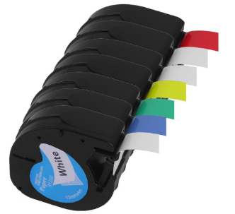 | No | Any | No | 5
20. | Sandpaper | - Sandpaper (120-3000 grit)  Pack: 60 PCs | No | Any | No | 2 Pack
21. | Body Filler Kit | - Body Filler Kit  - Size: 14oz  - Color: Salmon  - Suitable For: Wood, steel, aluminum, fiberglass, and concrete  Picture for reference only  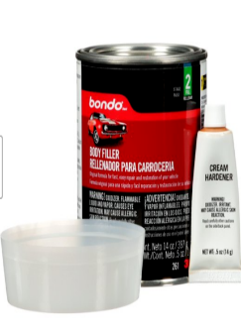 | No | Any | No | 1
22. | Filler & Sandable | - Rust-Oleum 260510 Automotive 2-in-1 Filler & Sandable, 12 Ounce  Picture for reference only | No | Any | No | 2
23. | Ferric Chloride | Ferric Chloride (Powder) | Kg | Any | No | 1
24. | TOUGH MATERIAL LARGE SPOOL | - TOUGH MATERIAL LARGE SPOOL FOR REPLICATOR+ SERIES  - Spool Diameter: 25.0 cm (9.84 in)  - Spool Width: 4 cm (1.57 in)  - Spool Hub Hole: 5.08 cm (2 in)  - Material Diameter: 1.75 mm  - Net Weight: 0.9 kg (2 lb)  - Color: White  Picture for reference only  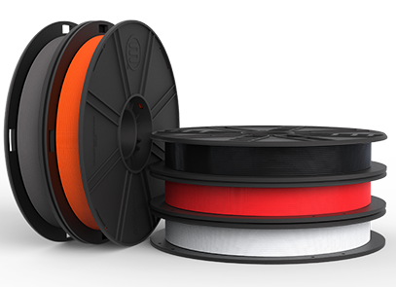 | No | Any | Yes | 1
 | Net Total (without taxes)
 | Total taxes
 | Gross Total inclusive of all taxes

- Provide unit price of each item, Total price per item, Total price of all item without all applicable taxes and total price with all taxes.
- Quote for above mentioned items should be on company’s letterhead with sign and stamp.
- Also mention date of quote, NTN and STRN number in your quotation.
- Quotes must reach in SCM Office 2nd Floor Admin Block NUTECH Islamabad latest
by 13 January 2023 not later than 1100 hrs.
- Quotes will be opened on 13 January 2023.
- Delivery period will be 30 days after placing Purchase Order (90 Days for Sr. 12, 13, 14, & 15 only).
- Please ensure delivery within stipulated time.
- Rates shall be quoted on free delivery basis at NUTECH Islamabad.
- 100% payment will be made after successful completion of the order.
- LD will be imposed on late delivery, 1% LD for per 15 days shall be charged.
- Validity of offers shall be 30 days.
- Partial delivery shall not be allowed. The firm will email one-day prior before the date of delivery.
14. Copy of SECP & NTN Registration of the firm is required.

Deputy Assistant Director
Supply Chain Management Office

